From ¥18,000 From ¥15,000
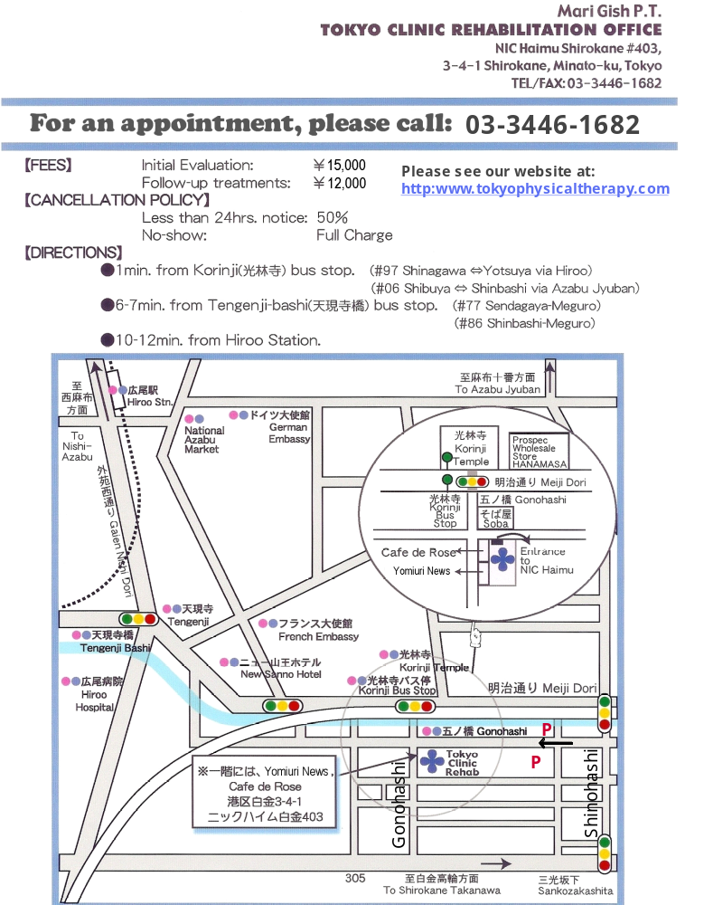
[HOME VISITS] Please enquire
From ¥18,000 From ¥15,000

